MECHATRONIC SYSTEM INTEGRATION
(MCTA 3203)

SEMESTER 2,2025/2026

EXPERIMENT 3 :

DESIGNING A MOTION-ACTIVATED RFID SYSTEM

(MCTA 3203)

SECTION 1

GROUP 8

NO. | MATRIC NO. | NAME
1 | 2416289 | MUHAMMAD IRFAN HAKIMI BIN MOHD RIZUAN
2 | 2128653 | MUHAMMAD NAJMI BIN MOHD AZAM
3 | 2120279 | MUHAMMAD SHAHABUDIN BIN ISHAK

SUBMISSION DATE : 1 APRIL 2026
ABSTRACT

This experiment explores real-time motion sensing and gesture recognition using the MPU6050 Inertial Measurement Unit (IMU) interfaced with an Arduino Mega 2560. The objective was to establish serial communication between the microcontroller and a computer, enabling data acquisition and processing of accelerometer and gyroscope readings. The MPU6050 sensor was connected to the Arduino via the 12C protocol, and the collected motion data was transmitted to a Python script for real-time analysis and visualization. The experiment successfully classified predefined hand gestures based on threshold-based motion detection. The accelerometer and gyroscope readings revealed distinct movement patterns, conforming the system’s ability to differentiate between right-hand and left-hand gestures. The results demonstrated the feasibility of using an MPU6050 based system for motion tracking applications, including robotics, human-computer interaction and wearable technology. Key challenges included sensor noise, gyroscope drift, and variations in user movement. Future improvements could incorporate filtering techniques, wireless communication, and enhanced data visualization. The findings validate the MPU6050 potential in real-time gesture recognition and motion tracking, providing a foundation for further research in embedded systems and automation.

TABLE OF CONTENT

PART 1: Interactive Motion Detection with MPU6050 5
INTRODUCTION 5
1.0 MATERIALS AND EQUIPMENT 6
1.1 EXPERIMENTAL SETUP 6
1.2 METHODOLOGY 7
a. HARDWARE ASSEMBLY 7
b. CIRCUIT ASSEMBLY 8
DATA COLLECTION 12
DATA ANALYSIS 12
RESULT 12
PART 2 : Introduction to RFID Integration 14
MATERIALS AND EQUIPMENT 14
EXPERIMENTAL SETUP 14
METHODOLOGY 14
CODE USED 15
DATA COLLECTION 16
DATA ANALYSIS 16
RESULTS 16
DISCUSSIONS 17
CONCLUSION 18
PART 3: RFID + Servo Access System 19
3.0 MATERIALS AND EQUIPMENT 19
3.1 EXPERIMENTAL SETUP 19
3.2 METHODOLOGY 19
a. Circuit assembly 19
b. Programming 19
c. Programming Logic 19
d. Coding 19
3.3 DATA COLLLECTION 19
3.4 DATA ANALYSIS 19
3.5 RESULT 19
3.6 DISCUSSION 19
3.7 CONCLUSION 19
RECOMMENDATION 19
REFERENCES 19
APPENDICES 19
ACKNOWLEDGEMENT 19
STUDENTS DECLARATION 19

PART 1: Interactive Motion Detection with MPU6050

INTRODUCTION

In modern embedded systems, real-time motion sensing and data acquisition play a crucial role in applications such as robotics, gesture recognition, and human-computer interaction. This experiment focuses on serial communication between a microcontroller and a personal computer using MPU6050 Inertial Measurement Unit (IMU), interfaced with an Arduino board. The MPU6050 is a widely used sensor that integrates a 3-axis accelerometer and a 3-axis gyroscope, providing precise motion and orientation data. This helps to measure acceleration, velocity, orientation, displacement and many other motion-related parameters of a system or object.
The primary objective of this experiment is to establish communication between the MPU6050 and a computer through the Arduino microcontroller, using serial communication. The sensor data obtained includes acceleration and rotational velocity values, which are then transmitted to the computer for processing using Python. By successfully setting up this system, we aim to develop a basic hand gesture recognition system that can classify predefined hand movements based on accelerometer and gyroscope readings. Additionally, the experiment aims to visualize hand movement paths in an x-y coordinate system using the collected sensor data.
The MPU6050 sensor is commonly used in motion tracking applications due to its ability to measure linear acceleration and angular velocity. The accelerometer component measures changes in velocity along the x, y, and z axes, while the gyroscope detects rotational motion. These measurements help determine an object’s orientation and movement patterns. The sensor communicates with the microcontroller via the Inter-Integrated Circuit (I2C) protocol, which allows efficient data transfer between devices using only two signal lines: Serial Data (SDA) and Serial Clock (SCL). Serial communication is essential for real-time data exchange between embedded systems and external devices. In this experiment, the Arduino’s serial port is used to send data from the MPU6050 to the computer, where a Python script processes the incoming data using the PySerial library. This approach allows for real-time monitoring and potential application in gesture-based control systems.
It is hypothesized that by successfully interfacing the MPU6050 sensor with the Arduino and establishing serial communication with the computer, real-time motion data can be captured and processed effectively. The accelerometer and gyroscope readings will provide sufficient information to distinguish different hand gestures based on predefined movement patterns. By implementing a threshold-based classification algorithm, the system should be able to detect and categorize specific gestures accurately. Furthermore, the data received on the computer will be visualized in an x-y coordinate system, allowing for a clear representation of hand movement paths. The expected outcomes of this experiment include the successful transmission of motion data via serial communication, accurate recognition of predefined gestures based on sensor readings, and effective visualization of movement patterns. These results will demonstrate the feasibility of using an MPU6050-based system for gesture recognition and motion tracking, which can be extended to applications in robotics, gaming, and human-computer interaction.

1.0 MATERIALS AND EQUIPMENT

The materials and equipment that we used in this experiment are:
a) Arduino Mega 2560 board
b) MPU6050 sensor
c) Breadboard
d) Jumper wires
e) LEDs of 2 colours
f) 220-ohm resistors

1.1 EXPERIMENTAL SETUP

1. The MPU6050 sensor was connected to the Arduino board using the appropriate pins. The SDA and SCL pins of the MPU6050 were connected to the corresponding pins on the Arduino Mega 2560, which are pin 20 (SDA) and pin 21 (SCL).
2. The INT pin of the MPU6050 was connected to D2 on the Arduino board.
3. The power supply and ground of the MPU6050 were connected to the Arduino's 5V and GND pins.
4. The LEDs were connected to the Arduino by attaching the longer leg (anode, +) of each LED to one end of each resistor, and the shorter leg (cathode, -) of each LED to the GND pin.
5. A 220-ohm resistor was used for each LED by connecting one end of each resistor to a separate digital pins D5 and D6, and the other end to the longer leg (anode, +) of each LED.
6. The Arduino board was connected to your PC via USB

1.2 METHODOLOGY

a. HARDWARE ASSEMBLY

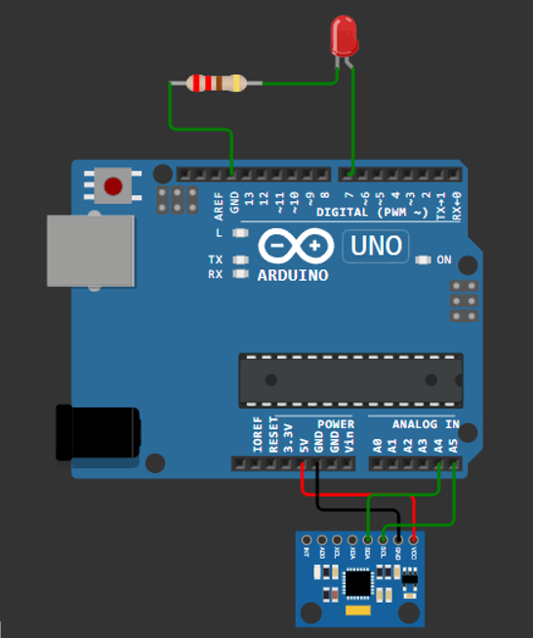
Figure 1. Arduino - MPU6050 Connections

b. CIRCUIT ASSEMBLY
- The VCC pin of the MPU6050 was connected to the 5V pin on the Arduino.
- The GND pin of the MPU6050 was connected to the GND pin on the Arduino.
- The SDA pin of the MPU6050 was connected to the A4 pin Arduino.
- The SCL pin of the MPU6050 was connected to the A5 pin on the Arduino.
- The LED pin was connected to the D7 pin on the Arduino.
- A 220 ohm resistor was connected to the GND pin on the Arduino.

c. SOFTWARE AND PROGRAMMING

CODE USED

TASK 1.1 : Capture real-time accelerometer X-Y data.

Arduino

#include <Wire.h>
#include <MPU6050.h>

MPU6050 mpu;

// --- DEFINE YOUR LED PIN HERE ---
const int ledPin = 7; // Fill in

void setup() {
Serial.begin(9600);
Wire.begin();
mpu.initialize();

if (!mpu.testConnection()) {
Serial.println("MPU6050 connection failed!");
while (1);
}

pinMode(ledPin, OUTPUT);
digitalWrite(ledPin, LOW); // Start with LED off
}

void loop() {
// 1. Read motion data
int16_t ax, ay, az, gx, gy, gz;
mpu.getMotion6(&ax, &ay, &az, &gx, &gy, &gz);

// 2. Send formatted data to Python (ax,ay,az)
Serial.print(ax); Serial.print(',');
Serial.print(ay); Serial.print(',');
Serial.println(az);

// 3. Listen for commands from Python to control the LED
if (Serial.available() > 0) {
char cmd = Serial.read();
if (cmd == '1') {
digitalWrite(ledPin, HIGH); // Turn LED ON
}
else if (cmd == '0') {
digitalWrite(ledPin, LOW); // Turn LED OFF
}
}

delay(50); // Small delay for stability
}

TASK 1.2 : Python Script (Motion Detection & Debouncing)

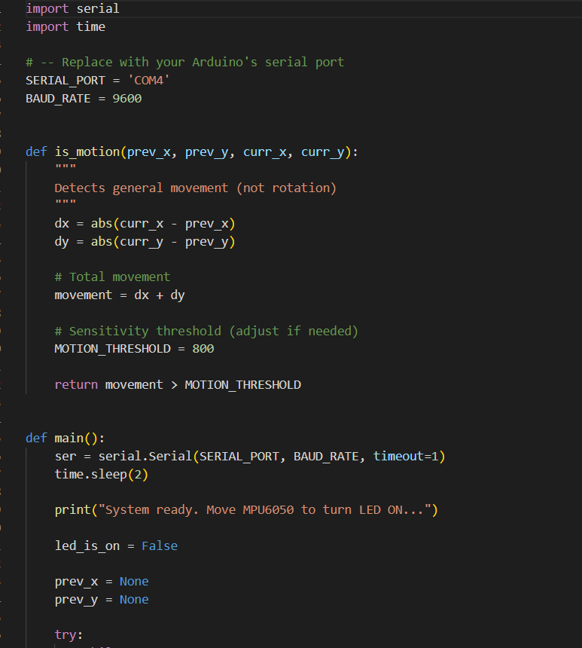
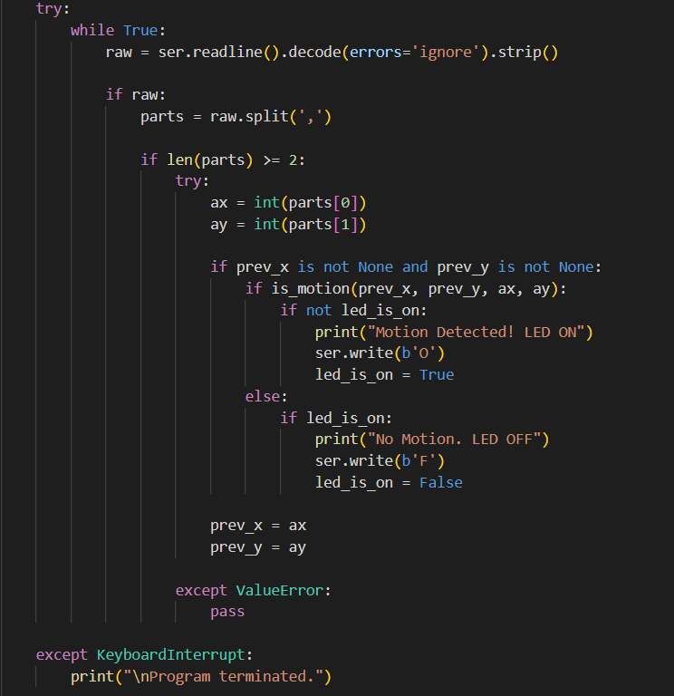
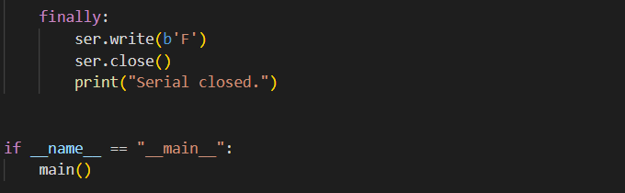

DATA COLLECTION

Command | LED
1 | ON
0 | OFF

DATA ANALYSIS

The MPU6050 utilizes a Micro-Electro-Mechanical System (MEMS) accelerometer to detect spatial orientation. Internally, it features microscopic proof masses suspended by capacitive silicon structures. When the sensor undergoes physical tilt or acceleration, gravity exerts force on these proof masses, causing them to deflect along the X, Y, and Z axes. This physical deflection alters the internal capacitance, which the onboard Analog-to-Digital Converter (ADC) instantly measures and converts into raw 16-bit integer values (ax, ay, az). The Arduino retrieves these exact voltage-derived measurements via the I2C protocol to determine the sensor's physical angle in real time.
The LED control mechanism operates through bidirectional serial communication between the microcontroller and the host PC. The Arduino continuously polls the serial input buffer using the Serial.available() function. Once the Python script processes the incoming motion data and determines that a specific threshold is met, it transmits a discrete ASCII character down the serial line. When the Arduino reads a '1' via Serial.read(), it executes digitalWrite(ledPin, HIGH), supplying 5V to the pin to energize the LED. Conversely, if it receives a '0', it pulls the pin to a LOW state, grounding the circuit and de-energizing the LED.

RESULT

From Arduino coding.
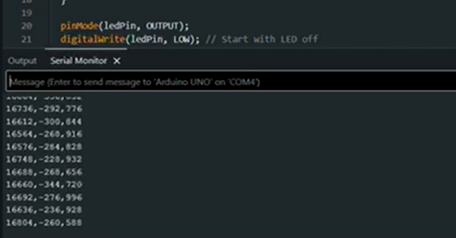
This means that the MPU is capturing raw data.

From Phyton coding.

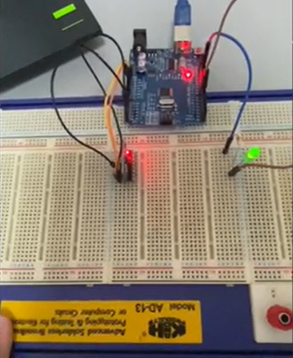  Figure 1.2 shows the LED turns ON when there is swirl. | 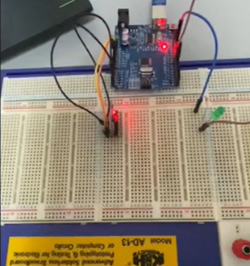  Figure 1.3 shows the LED turns OFF when there is no movement.

PART 2 : Introduction to RFID Integration

MATERIALS AND EQUIPMENT

The materials and equipment that we used in this experiment are:
a) Arduino Mega 2560 board
b) RFID card reader
c) RFID tags or cards
d) Servo motor
e) Breadboard
f) Jumper wires
g) Red and green LEDs
h) 220-ohm resistors
i) USB cable

EXPERIMENTAL SETUP

Here are the steps of equipment and components that were set up for the experiment:
1) The servo's signal wire was connected to a PWM-capable pin which is pin D9 on the Arduino.
2) The servo was connected to the 5V and GND pins on the Arduino.
3) The LEDs were connected to the Arduino by attaching the longer leg (anode, +) of each LED to one end of each resistor, and the shorter leg (cathode, -) of each LED to the GND pin.
4) A 220-ohm resistor was used for each LED by connecting one end of each resistor to a separate digital pins D5 and D6, and the other end to the longer leg (anode, +) of each LED.
5) RFID was connected to the computer via USB.

METHODOLOGY

Here are the steps followed during the experiment:

1) The circuit was built as shown in Figure 1 and the Arduino Mega 2560 was set up.
2) The RFID reader was connected to the computer via USB.
3) The Arduino code was created and uploaded to Arduino Mega 2560.
4) Python code was created to interact with the USB RFID reader.
5) Python code was set up to check if detected RFID tags were on an authorized list. If a card was recognized, an "A" signal was sent to the Arduino to move the servo. If not, a "D" signal was sent.
6) Testing was conducted by scanning both authorized and unauthorized RFID cards near the reader, verifying that the servo motor moved accordingly based on the signals received and green or red LED will light up based on authorized and unauthorized RFID cards.

CODE USED

Arduino

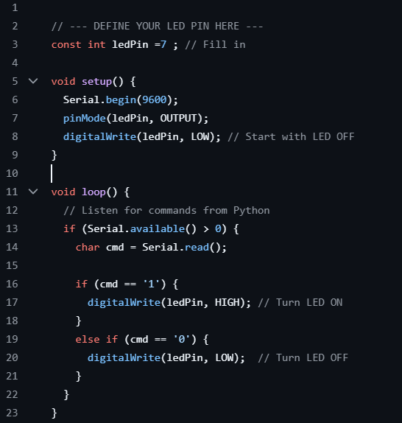

DATA COLLECTION

During the experiment, data was collected to examine the performance of a simulated RFID-based access control system. The system consisted of two primary components: a Python script run on a personal computer and an Arduino UNO microcontroller coupled with a servo motor. The Python script was responsible for simulating the detection of RFID card IDs and verifying whether each card was authorized. It then transmitted a corresponding command either 'A' for access granted or 'D' for access denied via serial communication (COM4) to the Arduino.
The Arduino received the command via its serial port and controlled the servo motor appropriately. Rotation to 180 degrees indicated that access was being granted, and rotation to 90 degrees indicated that access had been denied. This gave visual indication of the access decision.

DATA ANALYSIS

Analysis of data obtained through experiment is a proof of simulated RFID-based access control system performance and accuracy. The primary intention was to test whether the system was capable of properly reading authorized and unauthorized card IDs and triggering an appropriate response through movement in the servo motor. Python code matched the simulated RFID card IDs against an approved list of entries. Based on the outcome, it sent the character 'A' to indicate access granted or 'D' to indicate access denied to the Arduino using serial communication.
As soon as the command was given, the Arduino corrected the position of the servo motor 180 degrees to grant permission for access and 90 degrees to restrict access. The step served as the physical reaction for access determination. Four different card IDs were tried out during the experiment, and they included both valid and invalid input. In each case, the system responded as expected, resulting in an accuracy rate of 100%, calculated as (4 correct responses / 4 total attempts) × 100.
This outcome confirms that the interaction between the Arduino microcontroller and the Python environment was reliable and consistent. Moreover, the reaction of every command to the servo motor was prompt and precise, which confirms the logical structure used in both Arduino firmware and the Python script. The analysis confirms the system works as anticipated, with scope for extension to a fully functional RFID access control system using real RFID hardware and data logging.

RESULTS

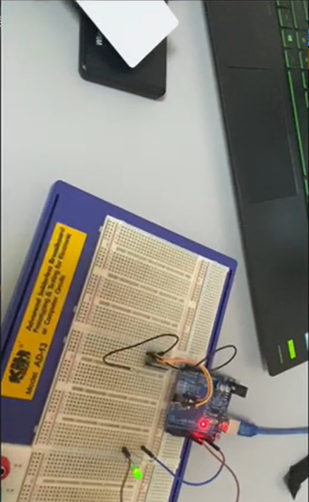  Figure shows the LED turns on when tapping the card. | 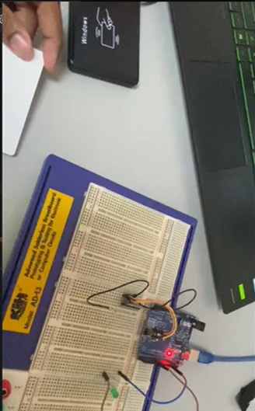  Figure shows the LED turns OFF when there is no cards

The results of the experiment confirm the successful simulation of an RFID-based access control system using a combination of Python and Arduino. The system correctly identified and processed both authorized and unauthorized card IDs. In each test case, the Arduino respond accurately to the serial command sent by the Python script, and the servo motor rotated to the correct position to reflect the access decision. As shown in Table 1, the system responded correctly to all four simulated card inputs, reflecting the expected behavior based on the access permissions.
The system achieved full accuracy, correctly granting or denying access based on the predefined list of authorized card IDs. The servo motor's precise movement and the consistency of serial communication demonstrate the robustness of the implemented logic and hardware control. These results validate the effectiveness of the simulated setup and indicate that it can serve as a functional prototype for more advanced security systems involving real RFID hardware, logging mechanisms, and additional access features.

DISCUSSIONS
The results of this experiment successfully validate the hypothesis that USB HID communication, when combined with structured serial interaction between Python and Arduino, can effectively simulate an RFID-based access control system. The system demonstrated full accuracy in processing predefined authorized and unauthorized RFID card IDs, controlling the servo motor and corresponding LEDs accordingly. This outcome reinforces the reliability and flexibility of integrating Python scripts for decision-making and Arduino for hardware control.
The incorporation of enhanced code using JSON data handling significantly improves the organization and scalability of the system. This structure allows not only a clear separation between control commands and configuration parameters (such as servo angle) but also opens the door to implementing more sophisticated logic in the future. The visual indicators, added through green and red LEDs, provided immediate and intuitive feedback about the access status, thereby enhancing the usability of the system. The option to dynamically control servo angles through JSON inputs further demonstrates the system's adaptability, aligning well with real-world applications where different levels of access might require different mechanical responses.
However, some discrepancies arose between the expected setup using the actual RFID IDR-232N reader and the simulated execution using hardcoded card IDs in Python. Due to technical issues with the COM port detection, the real RFID reader could not be integrated into the test environment. This deviation meant that real-time scanning and dynamic input were not achievable within the experimental timeframe. As a result, the test relied on static card IDs,limiting the system’s exposure to real-world scenarios such as inconsistent signal reception or noisy data from an actual reader.
Potential sources of error or limitations in the experiment include hardware compatibility issues, reliance on manual simulation, and lack of real-time user interaction. USB-to-RS232 voltage mismatches, improper driver installations, or outdated libraries might have contributed to the RFID reader’s detection issues. These technical limitations restrict the full evaluation of the system under real operating conditions. Furthermore, since the experiment involved only four test cases with simulated inputs, it does not account for edge cases or system stress tests that could reveal performance bottlenecks or logical flaws.
Despite these limitations, the experiment provided a strong proof of concept. The Arduino’s consistent response to serial inputs and the accuracy of the Python decision logic suggest a robust foundational system. Future implementations should prioritize resolving real hardware integration issues, expanding the dataset of card inputs, and adding logging features to improve traceability. Ultimately, this simulated setup demonstrates the practical viability of a cost-effective, customizable access control system, and sets the groundwork for a more comprehensive solution with real-world capabilities.

CONCLUSION
The experiment successfully demonstrated a simulated RFID-based access control system that integrates Python scripting with Arduino hardware. The system consistently distinguished between authorized and unauthorized card IDs and triggered the appropriate servo motor responses. This reliable performance, confirmed by a 100% accuracy rate in the conducted test cases, highlights the robustness of the logic implemented on both the software and hardware sides.
The experiment was initially intended to use the RFID IDR-232N reader to scan for real RFID card IDs. Unfortunately, due to technical issues specifically, the inability of the computer to detect the COM port of the RFID reader which makes it unable to proceed with that setup. Given the time limit to complete the experiment, we adjusted the approach by manually simulating the scanning process. Card IDs were initialized directly in the Python code rather than being read from actual RFID cards. While this adjustment removed real-time RFID input from the system, it allowed for continued testing of the access control logic and hardware response.
The main findings support the hypothesis that a simulated system can effectively replicate the behavior of a real RFID access control mechanism using simple serial communication and predefined logic. The accurate and prompt reactions of the servo motor serve as a clear indication of successful command execution and system reliability.
These results suggest that the prototype holds significant potential for broader applications, particularly in the development of cost-effective, customizable security solutions. With further enhancement such as integration of actual RFID readers, secure data logging, andmulti-level authentication, the system could evolve into a practical access control solution for schools, offices, or smart home environments.
One of the most significant implications of this experiment is its scalability. The structured JSON data handling and modular design of both hardware and software components make the system adaptable to larger and more complex environments, such as school entry systems, office security checkpoints, or smart home automation. The ability to customize servo angles, provide visual feedback, and process data in a structured format opens the door to more sophisticated features like biometric integration, remote monitoring, and cloud-based access management.
Moreover, this experiment reinforces the importance of robust communication protocols in embedded systems, particularly for real-time control and feedback. The combination of Arduino's simplicity and Python’s versatility proves to be a powerful tool for developing low-cost, customizable access control solutions that are both user-friendly and reliable. With additional enhancements, such as real-time RFID input, database connectivity for user tracking, and wireless communication, this prototype could evolve into a commercially viable security system for modern IoT applications.

PART 3: RFID + Servo Access System

3.0 MATERIALS AND EQUIPMENT

Arduino board + USB cable

MPU6050 sensor (Keep the I2C wiring from Part 1)

USB RFID Scanner + RFID tags/cards

1x Servo Motor (SG90)

1x Green LED & 1x Red LED

2x 220 Ω Resistors

3.1 EXPERIMENTAL SETUP

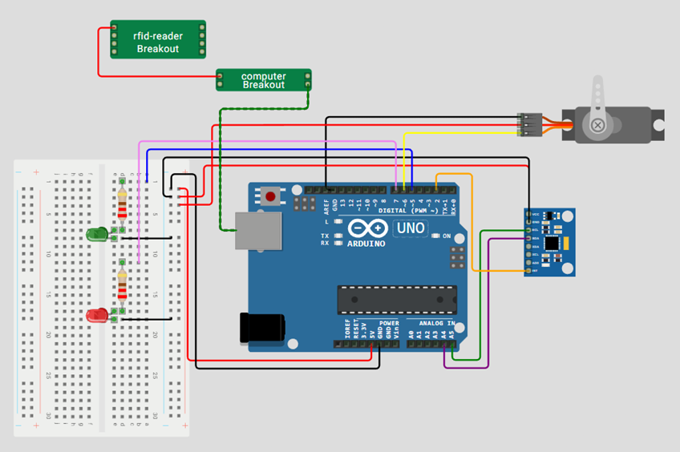

Figure 2. Shows the circuit connection of MPU 6050 and the USB RFID Scanner

3.2 METHODOLOGY

Circuit assembly
- The RFID reader is connected to the computer’s USB port.
- The Servo Motor signal is connected to D6, VCC to 5V, and GND to GND.
- The green LED is connected to the Arduino by attaching its positive leg to D5 digital pin, while its cathode is connected to ground through a 220Ω resistor.
- The red LED is connected to the Arduino by attaching its anode to D7 digital pin, while its cathode is connected to ground through a 220Ω resistor.

Programming Logic

- The system uses an MPU6050 motion sensor to detect movement, and when a command is received through the serial monitor, it checks for motion by comparing changes in acceleration values over time.
- If movement is detected, the green LED turns on, the red LED turns off, and the servo motor rotates to open the gate; if no movement is detected, the red LED stays on and the gate does not open.
- When a different command is received, the system closes the gate by rotating the servo back to its original position, and another command makes the red LED blink to indicate an alert.

Coding

ARDUINO

#include <Wire.h>
#include <MPU6050.h>
#include <Servo.h>

MPU6050 mpu;
Servo gateServo;

const int greenLedPin = 5;
const int servoPin = 6;
const int redLedPin = 7;

// Sensitivity (adjust if needed)
const int motionThreshold = 2000;

void setup() {
pinMode(greenLedPin, OUTPUT);
pinMode(redLedPin, OUTPUT);

gateServo.attach(servoPin);
gateServo.write(90);

Serial.begin(9600);
Wire.begin();
mpu.initialize();

if (!mpu.testConnection()) {
Serial.println("MPU6050 connection failed!");
while (1);
}

digitalWrite(redLedPin, HIGH);
digitalWrite(greenLedPin, LOW);
}

void openGate() {
for (int pos = 90; pos <= 180; pos += 2) {
gateServo.write(pos);
delay(15);
}
}

void closeGate() {
for (int pos = 180; pos >= 90; pos -= 2) {
gateServo.write(pos);
delay(15);
}
}

bool detectMovement() {
int16_t ax, ay, az;
int16_t prev_ax, prev_ay, prev_az;

// Get initial reading
mpu.getAcceleration(&prev_ax, &prev_ay, &prev_az);

// Check movement over multiple samples
for (int i = 0; i < 20; i++) {
mpu.getAcceleration(&ax, &ay, &az);

if (abs(ax - prev_ax) > motionThreshold ||
abs(ay - prev_ay) > motionThreshold ||
abs(az - prev_az) > motionThreshold) {
return true;
}

prev_ax = ax;
prev_ay = ay;
prev_az = az;

delay(50);
}

return false;
}

void loop() {
if (Serial.available()) {
char cmd = Serial.read();

if (cmd == '1') {
Serial.println("Checking movement... Move sensor!");

if (detectMovement()) {
Serial.println("Movement detected!");

digitalWrite(greenLedPin, HIGH);
digitalWrite(redLedPin, LOW);
openGate();
} else {
Serial.println("No movement!");

digitalWrite(redLedPin, HIGH);
digitalWrite(greenLedPin, LOW);
}
}

else if (cmd == '0') {
digitalWrite(greenLedPin, LOW);
digitalWrite(redLedPin, HIGH);
closeGate();
}

else if (cmd == 'X') {
for (int i = 0; i < 3; i++) {
digitalWrite(redLedPin, HIGH);
delay(150);
digitalWrite(redLedPin, LOW);
delay(150);
}
digitalWrite(redLedPin, HIGH);
}
}
}

PYTHON

import serial
import time

# --- CONFIG ---
SERIAL_PORT = "COM4" # Change if needed (e.g., COM3)
BAUD_RATE = 9600
AUTHORIZED_ID = "0009522418"
# ---------------

def main():
try:
rduino = serial.Serial(SERIAL_PORT, BAUD_RATE, timeout=1)
time.sleep(2) # Wait for Arduino reset
except:
print("Error: Cannot connect to Arduino!")
return

print("System Ready. Waiting for RFID...")

try:
while True:
card = input("\nTap card: ").strip()

if card == AUTHORIZED_ID:
print("Card Accepted - Move sensor now!")

# Send command to Arduino
rduino.write(b'1')

# Read Arduino feedback
time.sleep(1)
while rduino.in_waiting > 0:
response = rduino.readline().decode().strip()
print("Arduino:", response)

else:
print("WRONG CARD -> Access Denied")
rduino.write(b'X')

except KeyboardInterrupt:
print("\nExiting program...")

finally:
rduino.write(b'0') # Ensure system locked
rduino.close()

if __name__ == "__main__":
main()

3.3 DATA COLLLECTION

Movement | LED
Tapping the card on RFID reader + Correct Motion | Green LED ON
Invalid RFID OR incorrect motion | Red LED ON

3.4 DATA ANALYSIS

The system collects acceleration data from the MPU6050 sensor along the x, y, and z axes, and continuously compares the current readings with previous readings to determine if there is significant movement. Movement is identified when the difference between consecutive acceleration values exceeds a defined threshold, which filters out small vibrations and only responds to noticeable motion. Based on this analysis, the system makes decisions: if movement is detected, it activates the green LED and opens the gate using the servo motor, while if no movement is detected, it keeps the red LED on and the gate closed, ensuring controlled and conditional operation.

3.5 RESULT
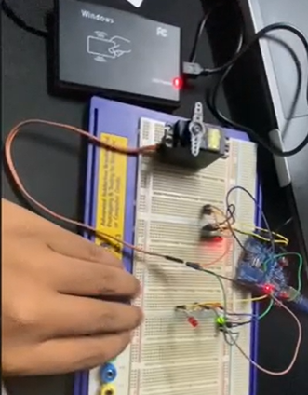  Figure 2.1 shows the Green LED is ON when the RFID is valid and the motion is correct. | 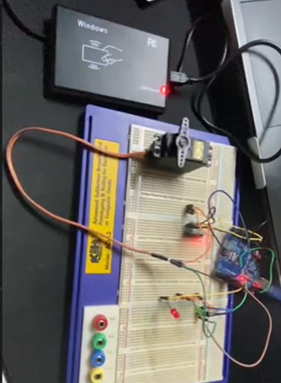  Figure 2.2 shows the Red LED is ON when the RFID is invalid OR the motion is incorrect.

3.6 DISCUSSION
The core of this setup is the communication bridge between the Python script and the Arduino firmware. In our implementation, the Arduino acts as the low-level hardware interface, constantly polling the RFID reader for a signal. The moment a tag enters the reader's electromagnetic field, the Arduino captures the unique ID and passes it through the Serial buffer to the Python environment. By offloading the "decision-making" to Python, we essentially create a more scalable system. Python handles the heavy lifting—comparing the incoming ID against a database of authorized users—which is much more efficient than hardcoding every possible ID directly into the Arduino's limited memory.
Once Python verifies the identity, it sends a specific command character back to the Arduino to trigger the physical response. The Arduino code is programmed to "listen" for these specific triggers; for example, a "success" character from Python tells the Arduino to toggle the digital pins for the LED indicators, switching the state from a standby red to an active green. Simultaneously, the Arduino initiates a pulse-sequence to the servo motor. Instead of a simple "on/off" command, the programming ensures the servo moves to a specific angular position to simulate a gate opening. This interaction perfectly illustrates a mechatronic hierarchy: Python acts as the high-level supervisor managing the data, while the Arduino serves as the real-time controller managing the physical hardware.

3.7 CONCLUSION

In conclusion, the experiment successfully demonstrated the integration of a Python-based logic system with an Arduino-controlled hardware platform to create a functional RFID access control system. By establishing a stable serial communication link between the two, we were able to offload the authentication process to Python, which allowed the Arduino to focus on real-time hardware execution. The project proved that we could effectively bridge the gap between high-level data processing and low-level physical actuation, where a simple tag scan triggers a coordinated response between the software verification, the LED status indicators, and the mechanical motion of the servo motor.
Overall, this setup highlights the core principle of mechatronics: the synergy between programming and physical hardware. Using Python as the "brain" for data management and the Arduino as the "actuator" for the gate mechanism provided an efficient and scalable approach to automation. This experiment serves as a solid foundation for developing more complex security systems where digital identity must be seamlessly translated into reliable, physical responses.

RECOMMENDATION

To improve system reliability, a dedicated power supply should be utilized for the servo motor to prevent voltage drops that could disrupt the microcontroller's logic. Upgrading from a basic servo to a solenoid door lock would also provide a more robust mechanical barrier, making the system more suitable for actual security applications rather than just a laboratory simulation.
Replacing local variable storage with a structured database within the Python environment would significantly improve the system's scalability. Implementing a logging feature would allow for a permanent record of all access attempts, including timestamps and unauthorized UID scans, which is essential for effective security monitoring and long-term data analysis.
Transitioning from a wired serial connection to a wireless communication protocol, such as Wi-Fi or Bluetooth, would increase the flexibility of the installation. Using an IoT-enabled microcontroller like the ESP32 would allow the access control system to be managed remotely, enabling real-time administrative control and monitoring through a web interface or mobile application.

REFERENCES

Instructables. (2016, December 5). Arduino + MFRC522 RFID READER. Instructables. https://www.instructables.com/Arduino-MFRC522-RFID-READER/
Last Minute Engineers. (2018, July 30). What is RFID? How It Works? Interface RC522 RFID Module with Arduino. Last Minute Engineers; Last Minute Engineers. https://lastminuteengineers.com/how-rfid-works-rc522-arduino-tutorial/
Santos, R. (2016, March 23). MFRC522 RFID Reader with Arduino Tutorial | Random Nerd Tutorials. Random Nerd Tutorials. https://randomnerdtutorials.com/security-access-using-mfrc522-rfid-reader-with-arduino/

APPENDICES

Figure 1. Arduino - MPU6050 Connections



Figure 2. Shows the circuit connection of MPU 6050 and the USB RFID Scanner

ACKNOWLEDGEMENT

We would like to express our deepest appreciation to our instructor, Assoc. Prof. Eur. Ing. Ir. Ts. Gs. Inv. Dr. Zulkifli Bin Zainal Abidin, for his invaluable guidance, continuous support, and constructive feedback throughout the completion of this project. His expertise and dedication have been instrumental in deepening my practical and theoretical understanding of mechatronics engineering. Furthermore, we are grateful to the Department of Mechatronics Engineering at the International Islamic University Malaysia for providing the necessary laboratory facilities and a conducive environment that made this work possible.

STUDENTS DECLARATION

We hereby declare that the work presented in this technical report is entirely our own, except where explicitly acknowledged. We certify that in developing and completing this mechatronics project, we have strictly adhered to the standards of academic integrity and have not engaged in any form of plagiarism or unethical conduct. All sources of information, reference materials, and technical support utilized in this work have been appropriately cited and acknowledged.

Certificate of Originality and Authenticity

This is to certify that we are responsible for the work submitted in this report, that the original work is our own except as specified in the references and acknowledgment, and that the original work contained herein has not been untaken or done by unspecified sources or persons. We hereby certify that this report has not been done by only one individual, and all of us have contributed to the report. The length of contribution to the reports by each individual is noted within this certificate. We also hereby certify that we have read and understand the content of the total report, and no further improvement on the reports is needed from any of the individual contributors to the report. We therefore agreed unanimously that this report shall be submitted for marking, and this final printed report has been verified by us.

Signature: IrfanHakimi Read[/]
Understand[/]
Name: Muhammad Irfan Hakimi Bin Mohd Rizuan Agree[/]
Matric : 2416289

Signature: Najmi Read[/]
Understand[/]
Name: Muhammad Najmi Bin Mohd Azam Agree[/]
Matric : 2128653

Signature: Shahabudin Read[/]
Understand[/]
Name: Muhammad Shahabudin bin Ishak Agree[/]
Matric : 2120279

